* **Create a table named "Employees" with columns for ID (integer), Name (varchar), and Salary (decimal).**

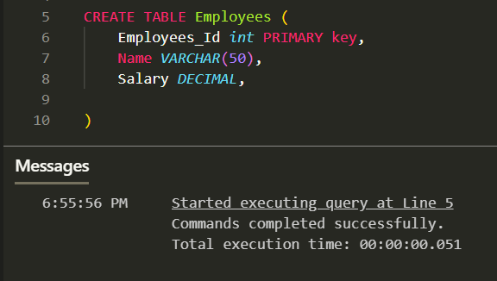

* **Add a new column named "Department" to the "Employees" table with data type varchar(50).**

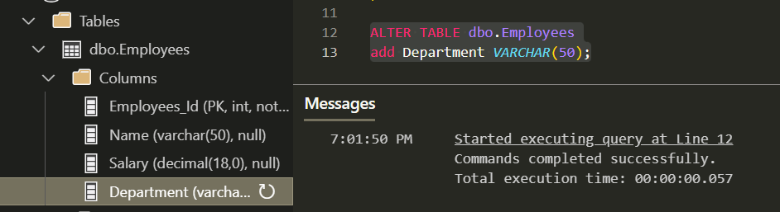

* **Remove the "Salary" column from the "Employees" table.**

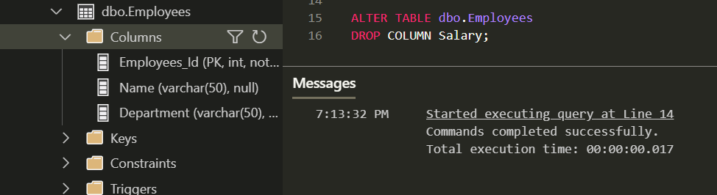

* **Rename the "Department" column in the "Employees" table to "DeptName".**

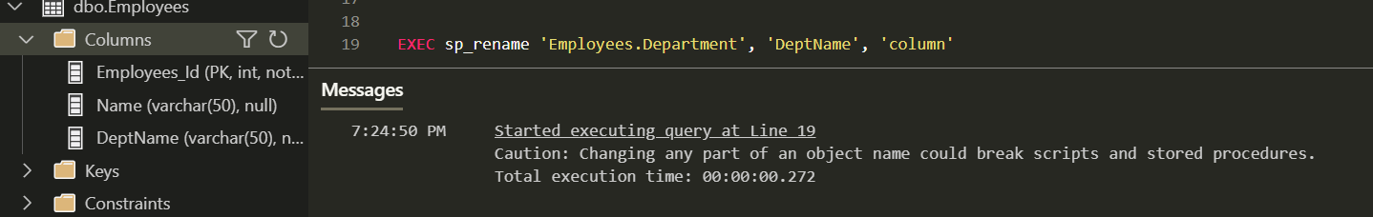

* **Create a new table called "Projects" with columns for ProjectID (integer) and ProjectName (varchar).**

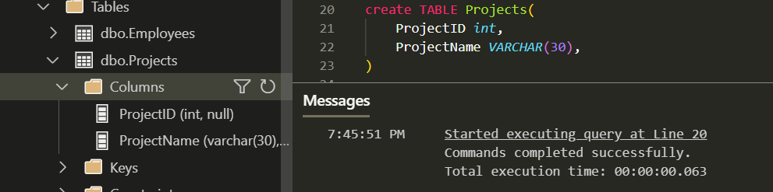

* **Add a primary key constraint to the "Employees" table for the "ID" column.**
* **انا هنا عملت DROP CONSTRAINT اني كنت عاملو فوق عشان الكود يشتغل**

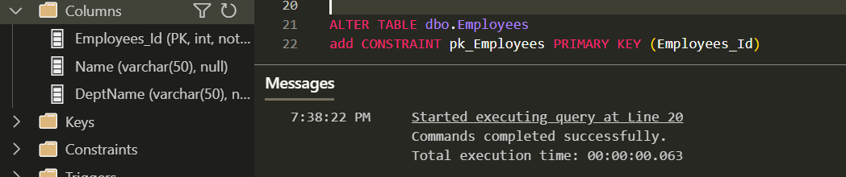

* **Create a foreign key relationship between the "Employees" table (referencing "ID") and the "Projects" table (referencing "ProjectID").**

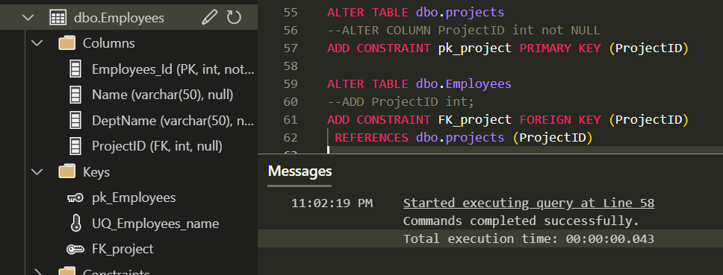

* **Remove the foreign key relationship between "Employees" and "Projects."**

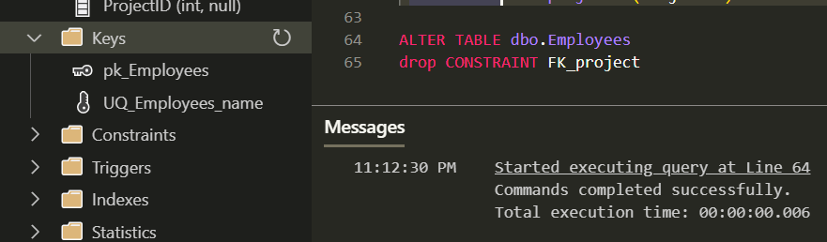

* **Add a unique constraint to the "Name" column in the "Employees" table.**

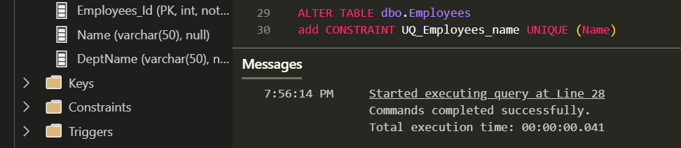

* **Create a table named "Customers" with columns for CustomerID (integer), FirstName (varchar), LastName (varchar), and Email (varchar), and Status (varchar).**

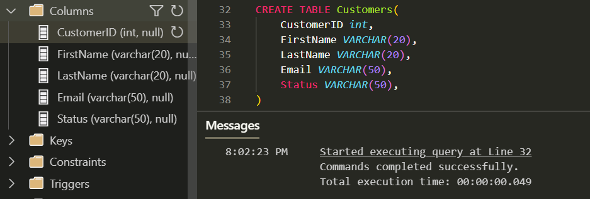

* **Add a unique constraint to the combination of "FirstName" and "LastName" columns in the "Customers" table.**

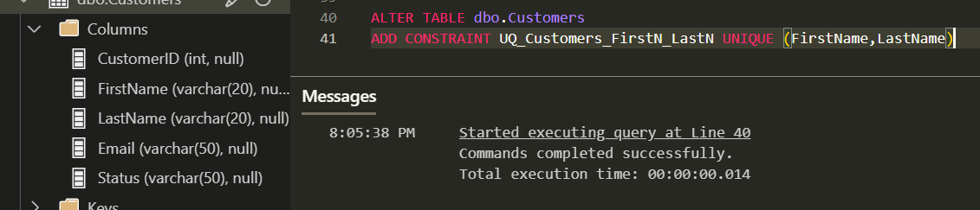

* **Add a default value of 'Active' for the "Status" column in the "Customers" table, where the default value should be applied when a new record is inserted.**

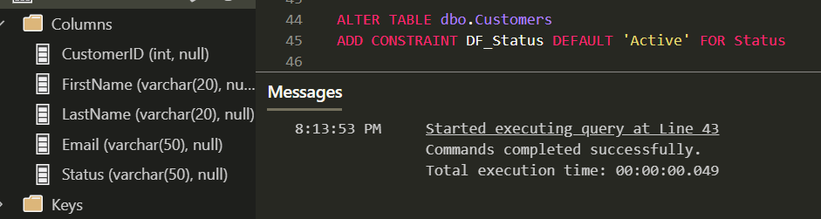

* **Create a table named "Orders" with columns for OrderID (integer), CustomerID (integer), OrderDate (datetime), and TotalAmount (decimal).**

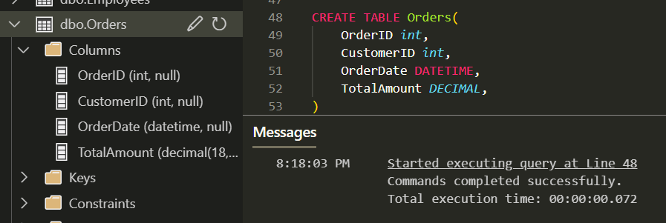

* **Add a check constraint to the "TotalAmount" column in the "Orders" table to ensure that it is greater than zero.**

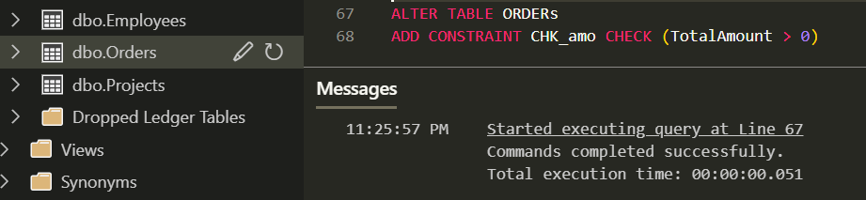

* **Create a schema named "Sales" and move the "Orders" table into this schema.**

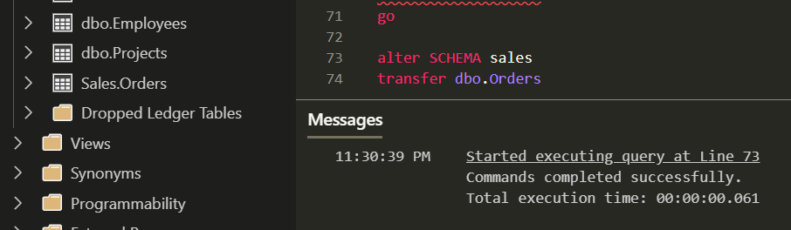

* **Rename the "Orders" table to "SalesOrders."**

